**POWERBI ASSIGNMENT**

**RUT CHOLERA**

**DATA LOADING**

Launching and connecting to sql server

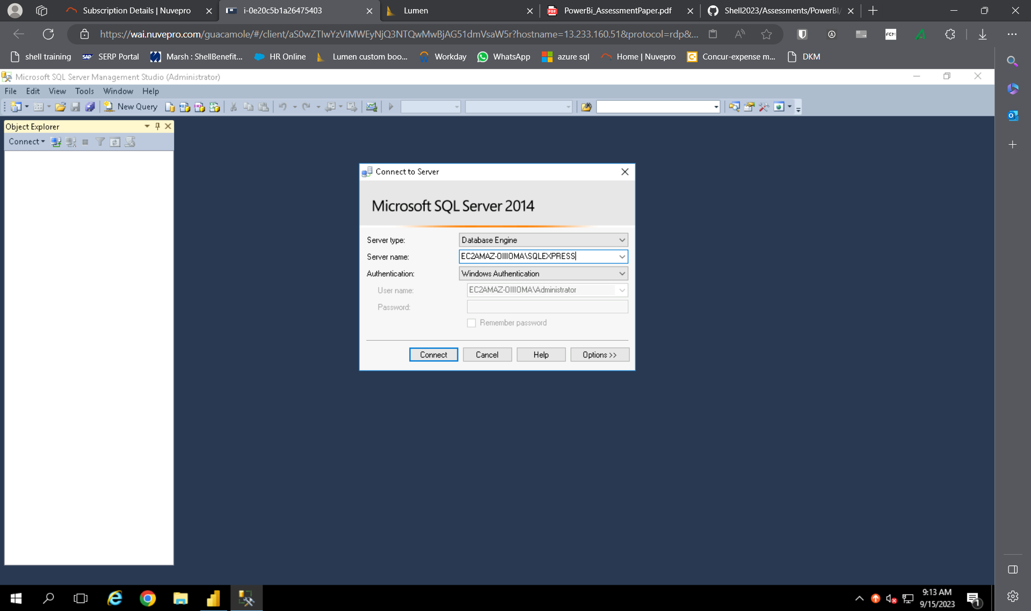

Executing query on sql server to create tables

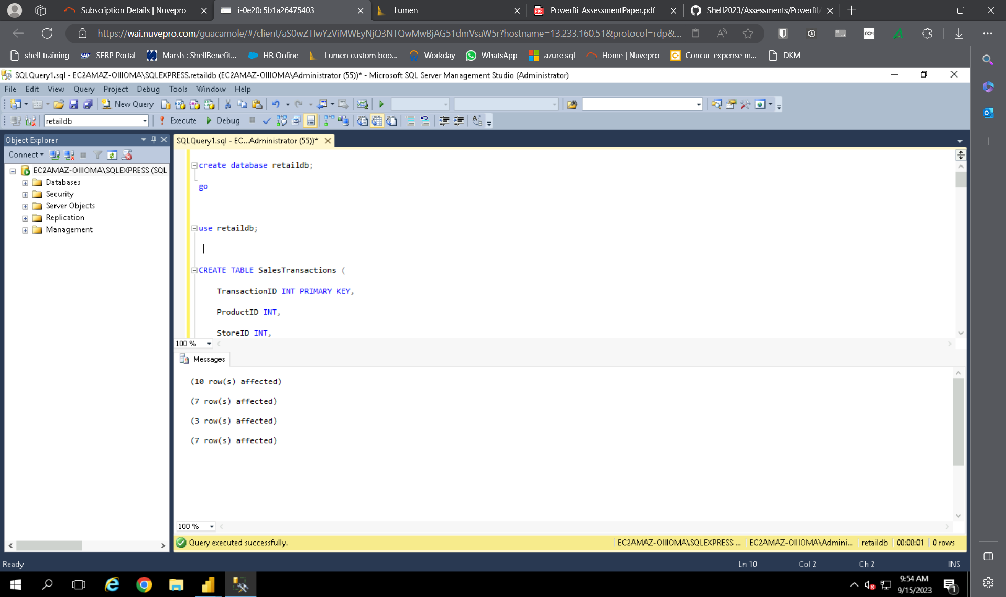

Launching powerbi and fetching sql server database:

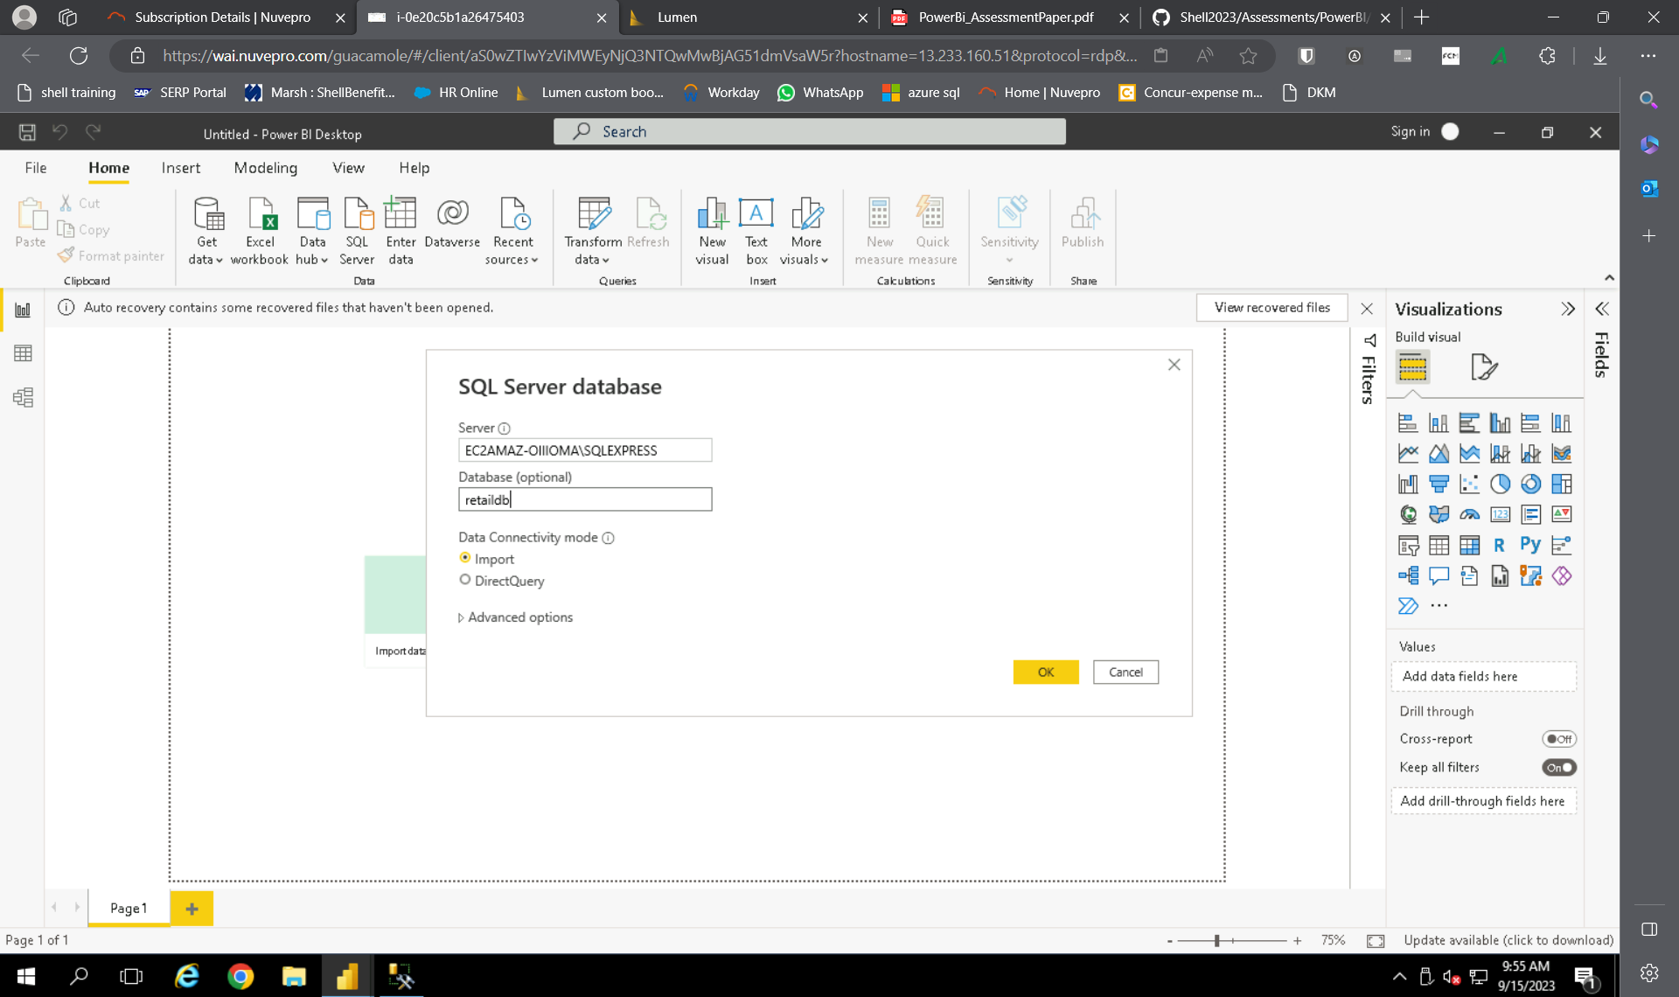

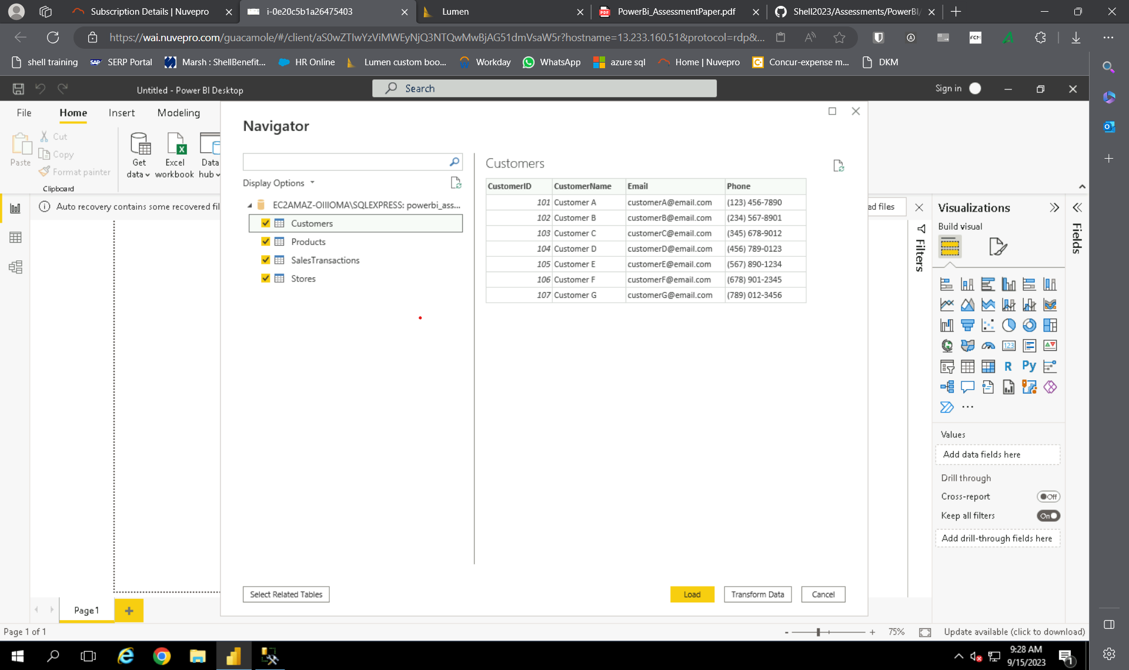

**DATA TRANSFORMATION:**

MERGING TABLES:

Merging salestransactions and product table

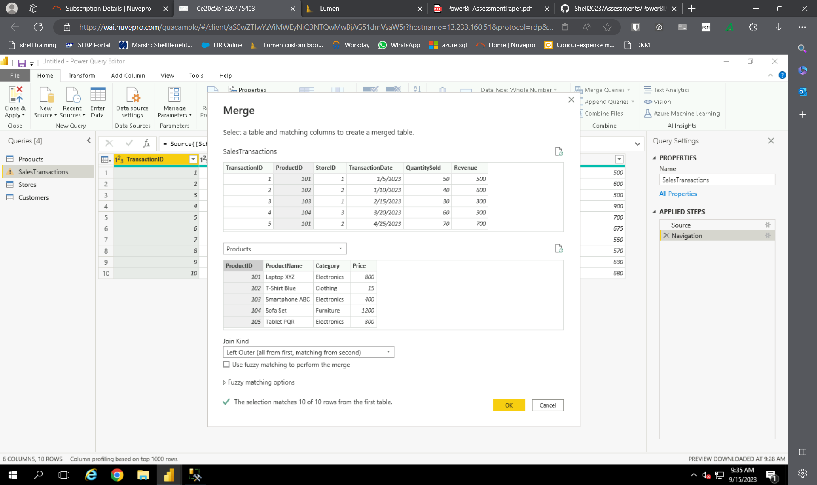

Merged table:

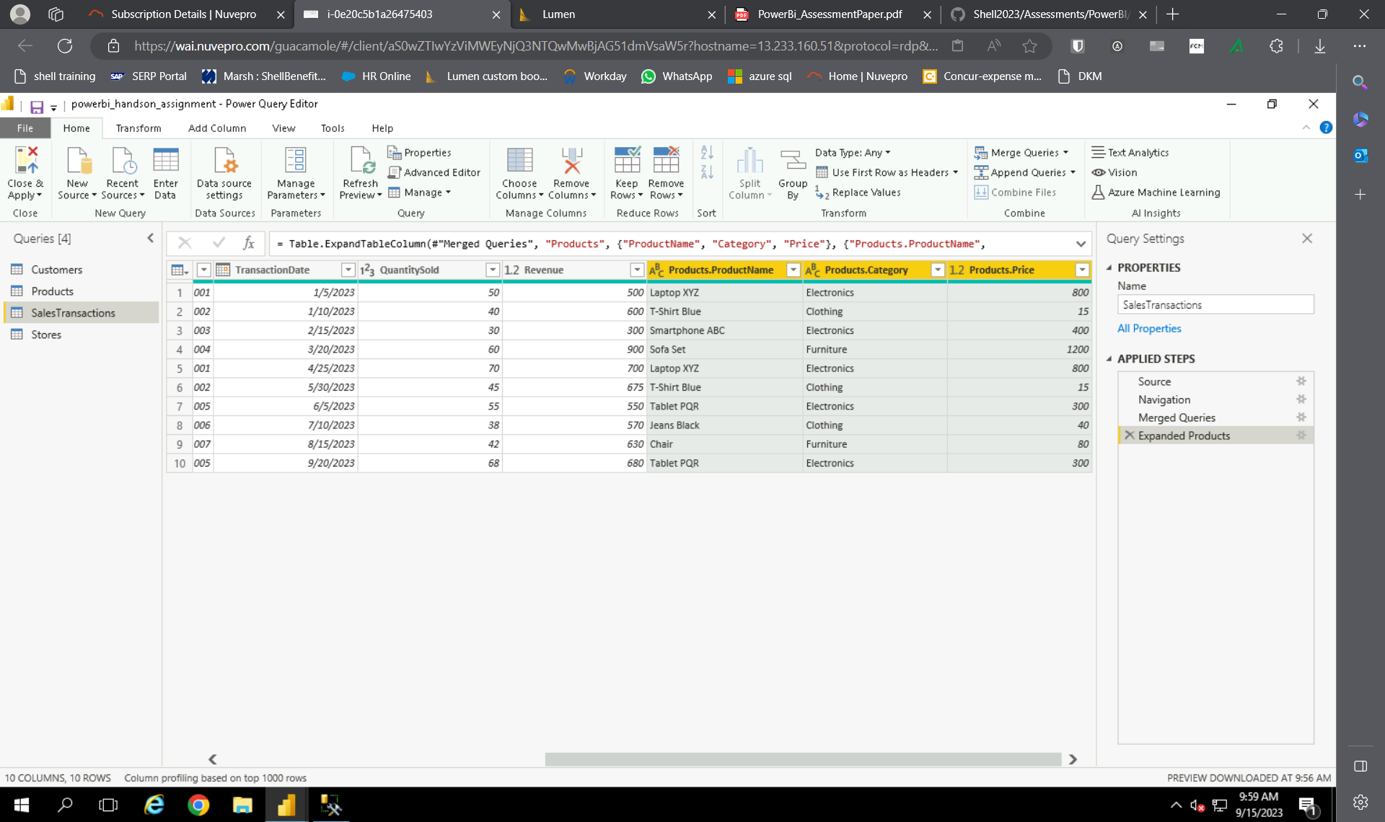

New salestransaction table:

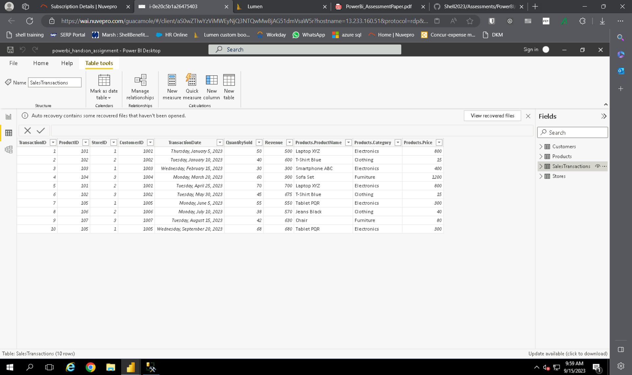

Clean data:

Removing empty values in all tables

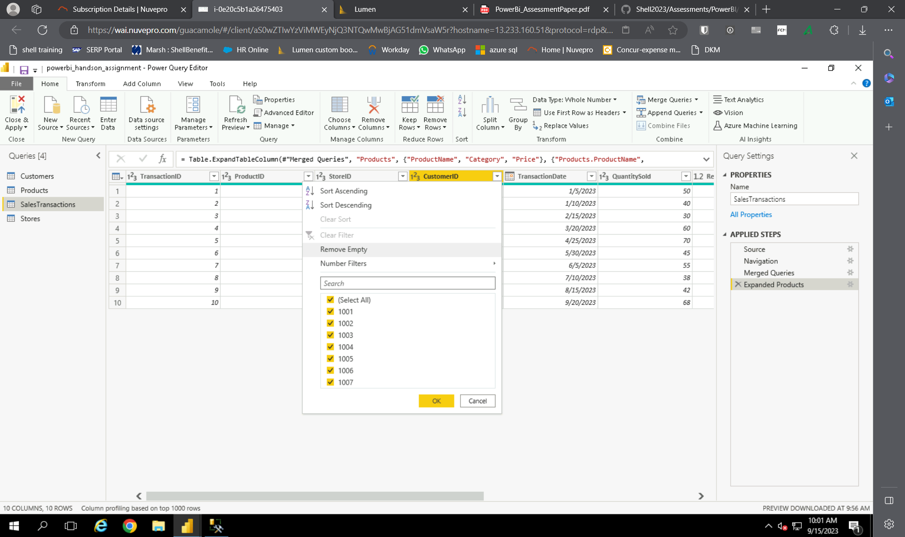

CREATING CALCULATED COLUMN:

We calculate revenue generated in a new column as old revenue column has dummy values

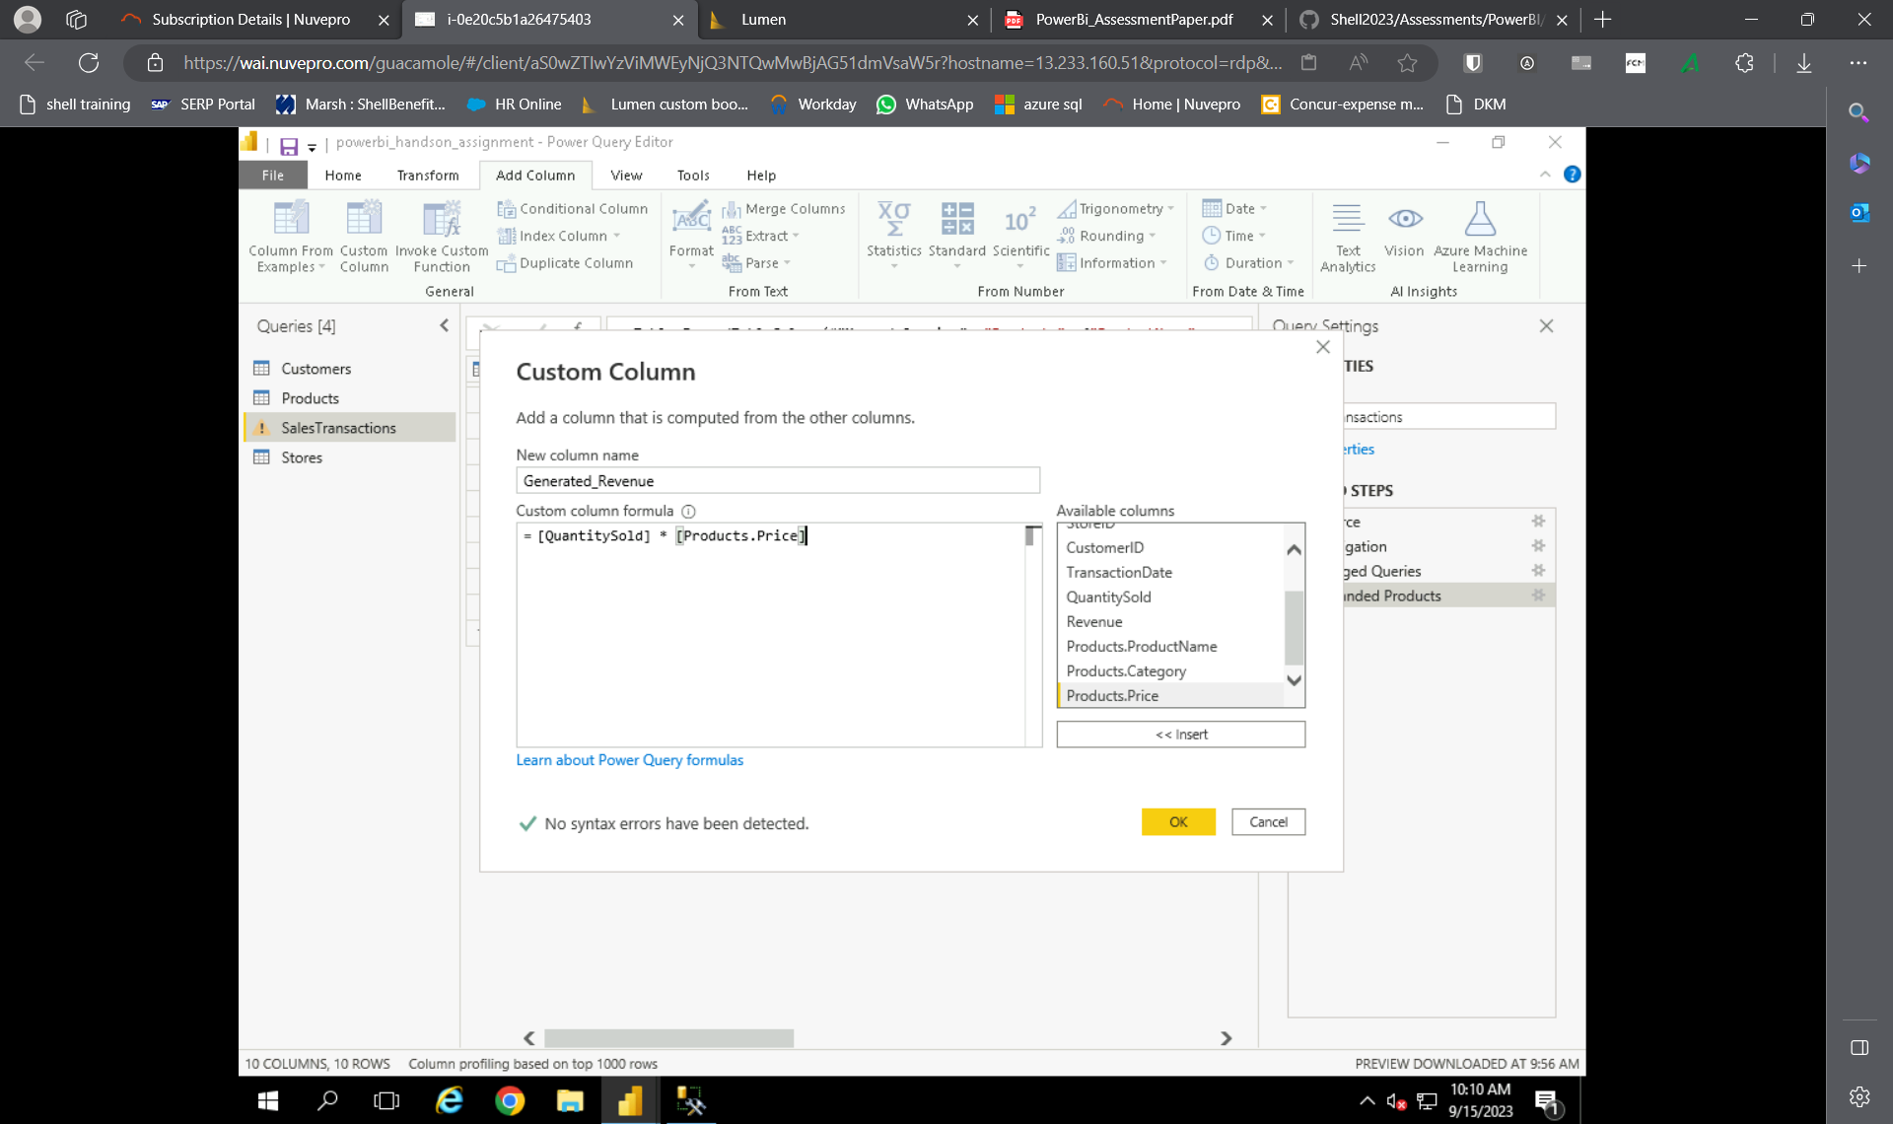

New column “generated_revenue”

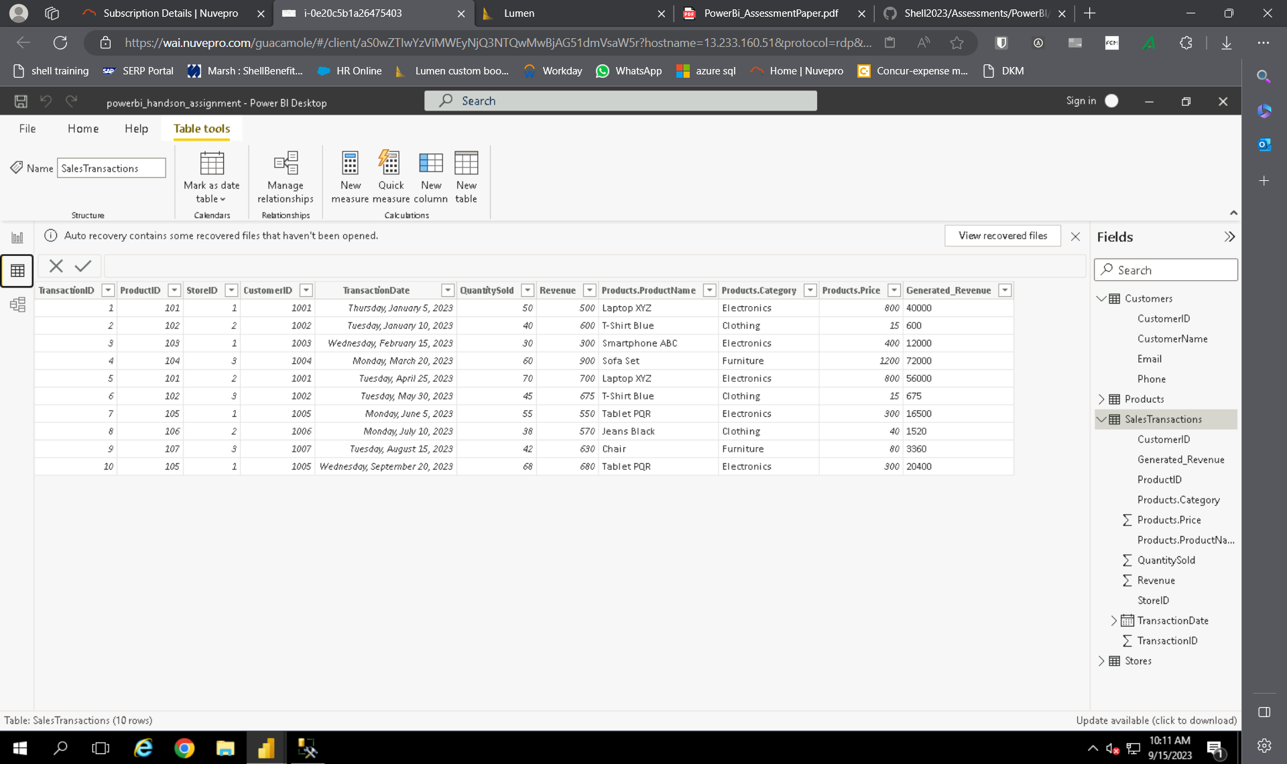

CREATING FILTER:

Creating a filter that shows data where quantity of products sold is more than 50

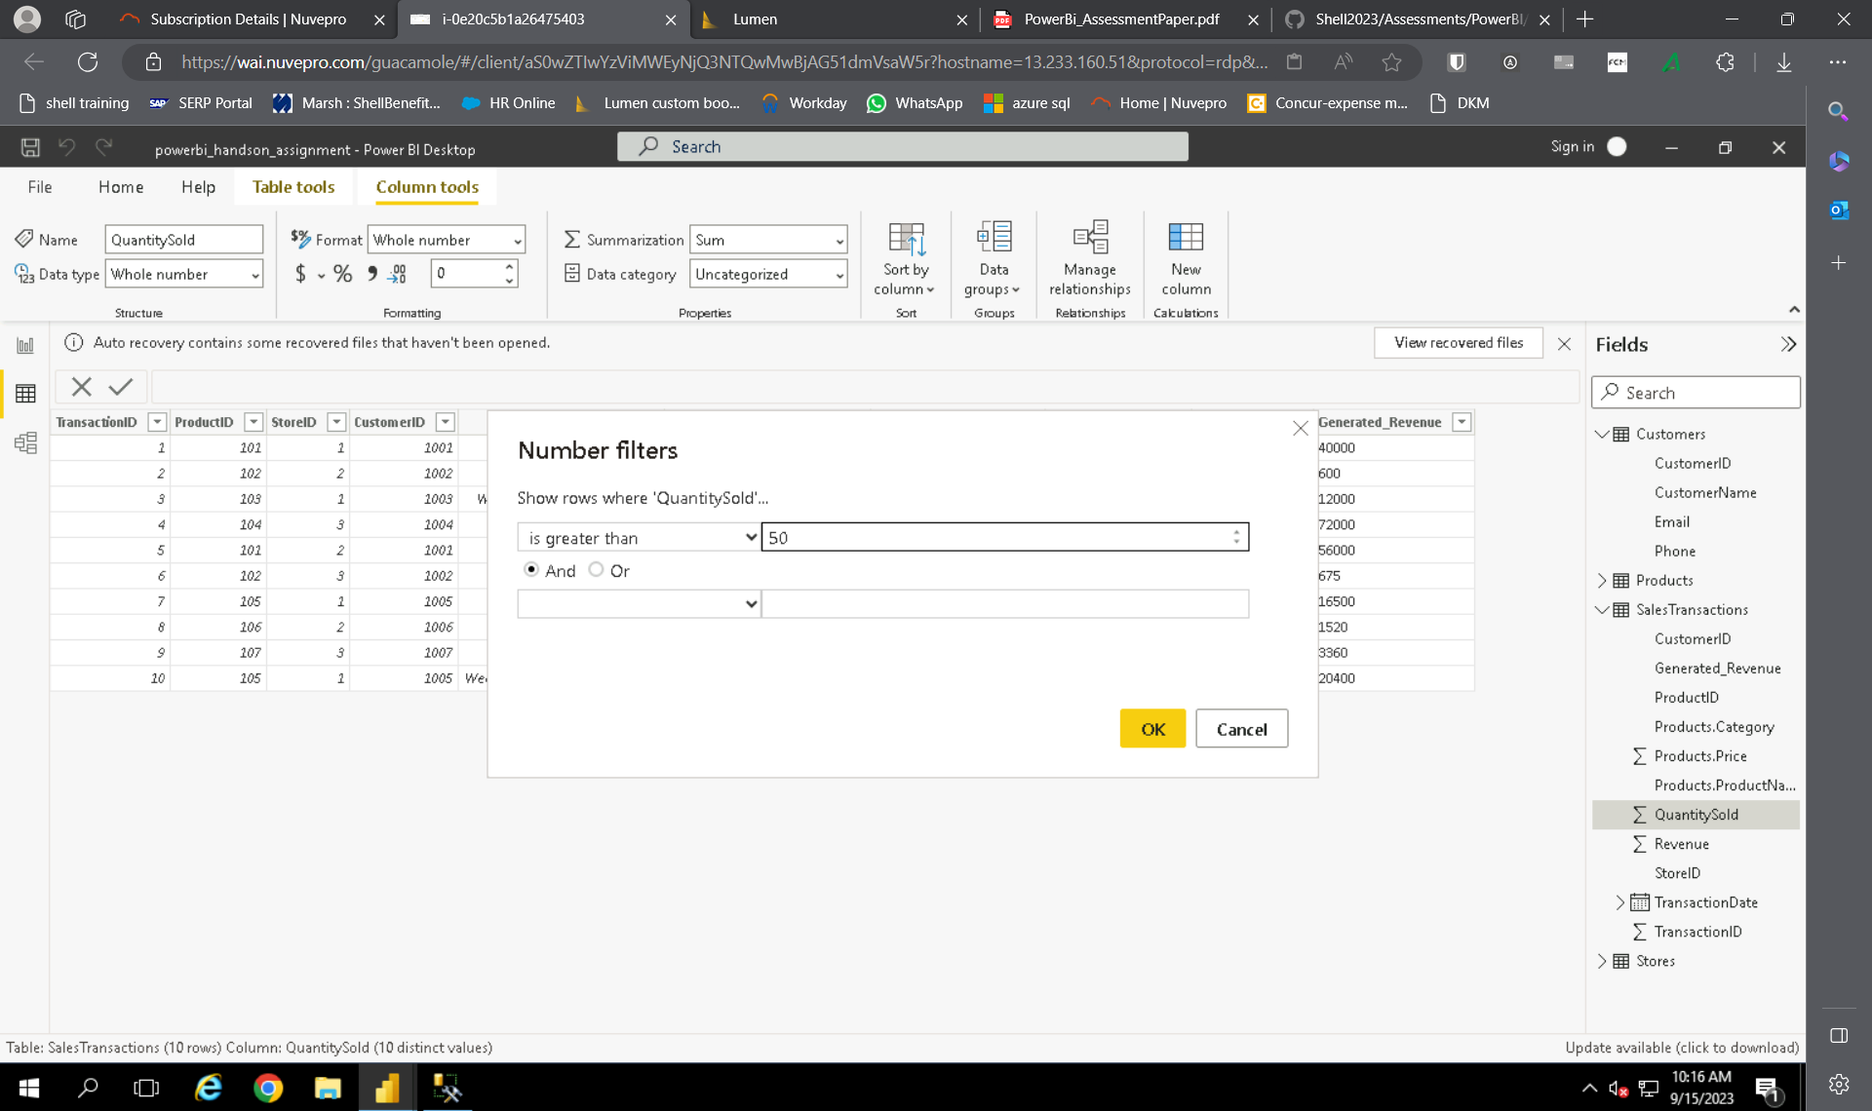

Filtered table:

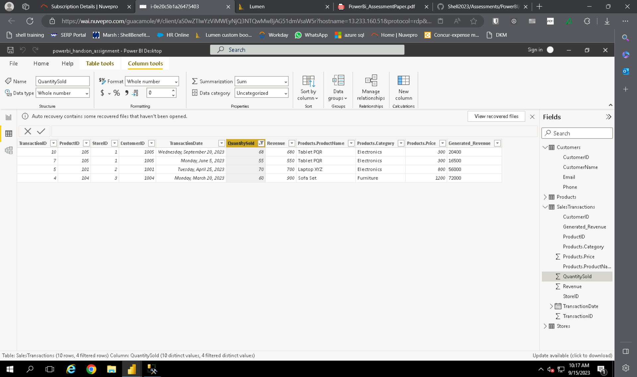

DATA MODELLING:

Creating relationships: relations between all the tables

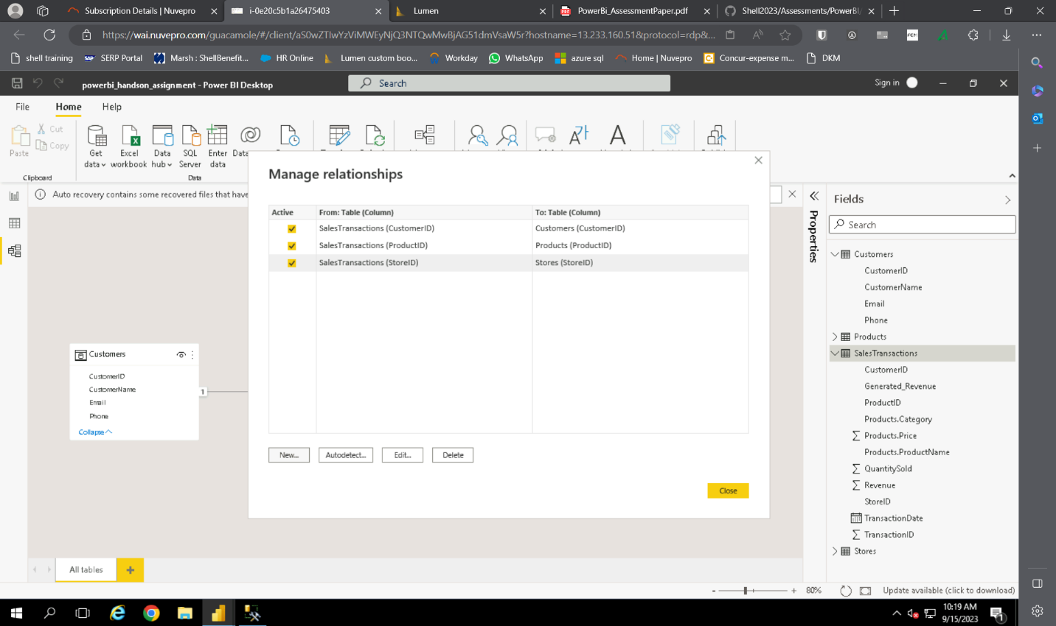  
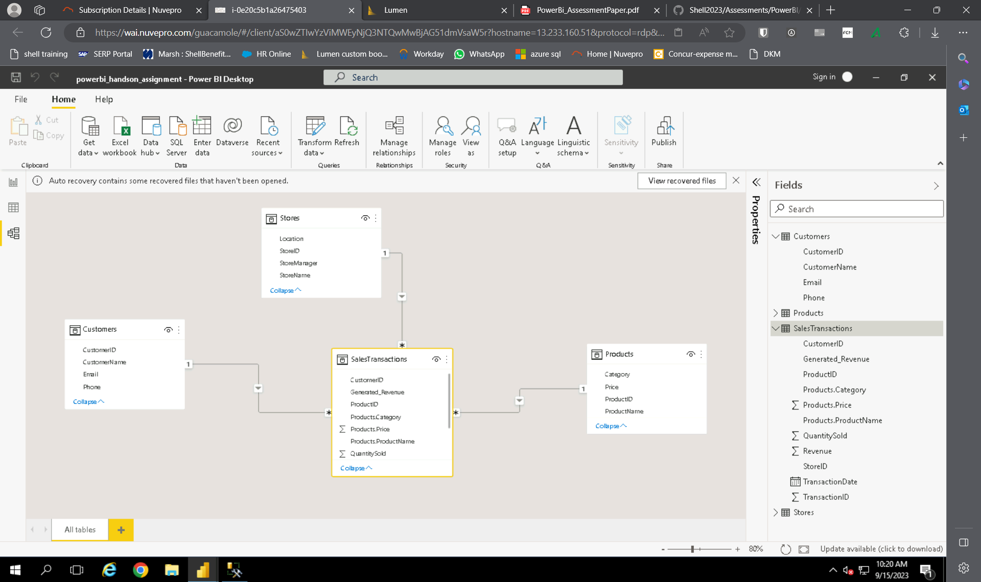

CREATING HIERARCHY:

Creating hierarchy in transactiondate column in salestransaction table:

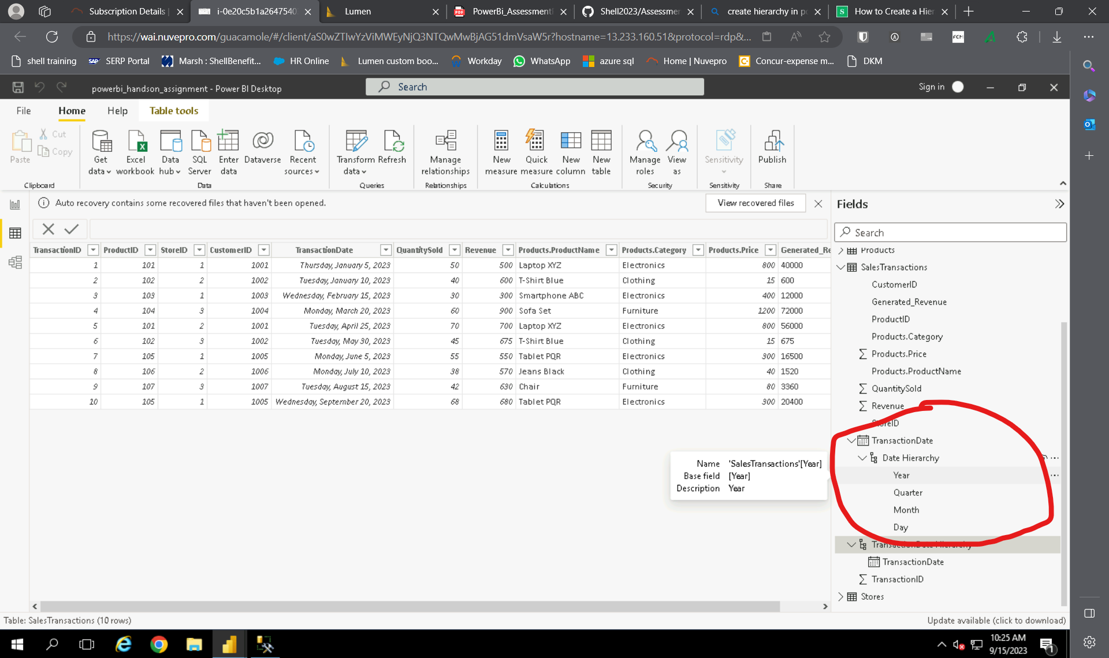

BUSINESS QUERIES:

1. Who are the top-spending customers based on their total purchase amount?

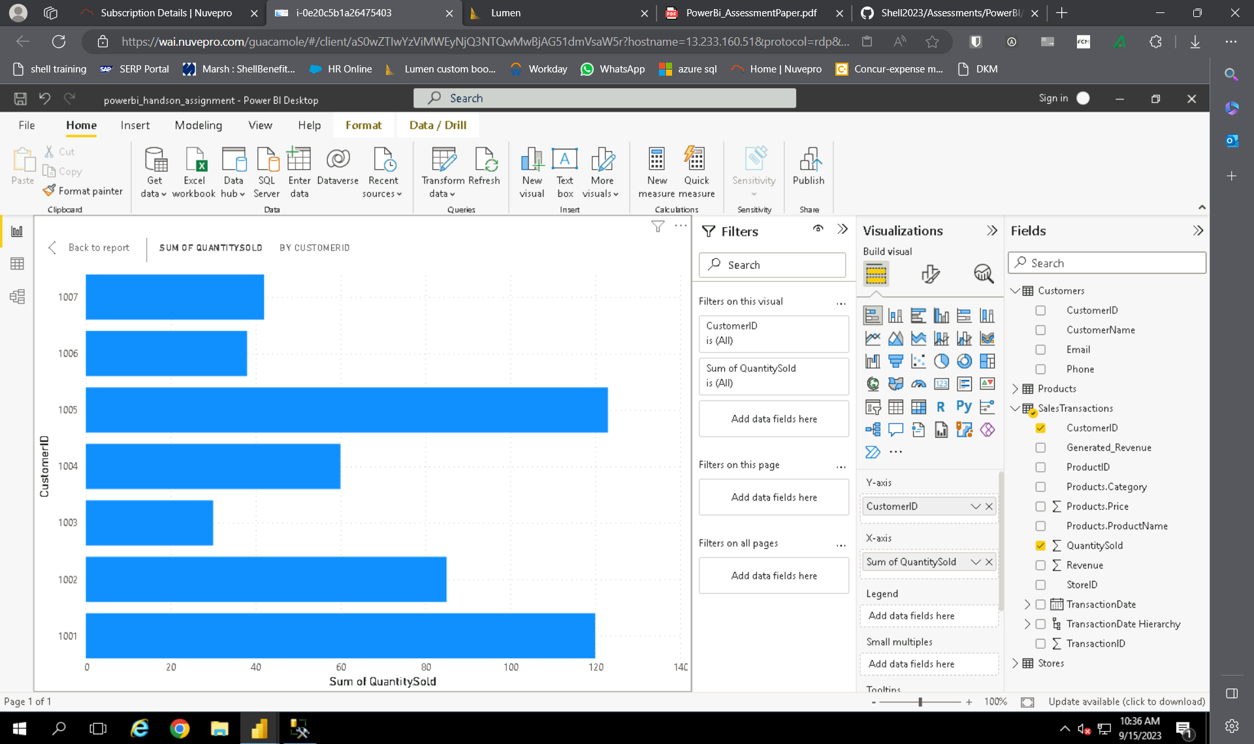

1. How is sales revenue distributed among different store managers?

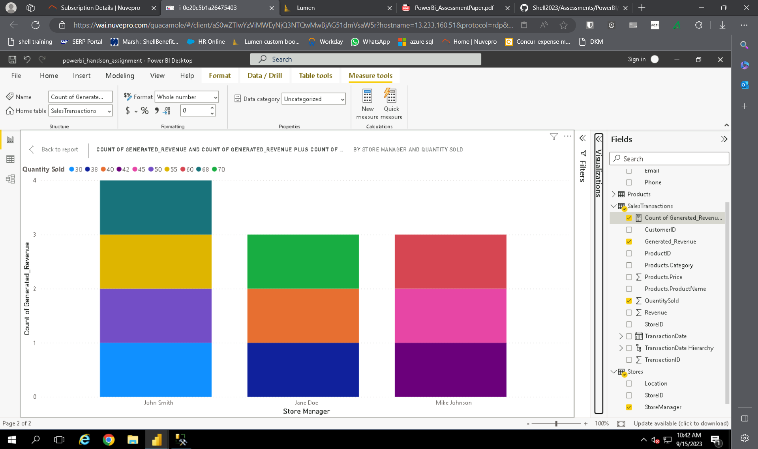

1. What is the average price of products in each category?

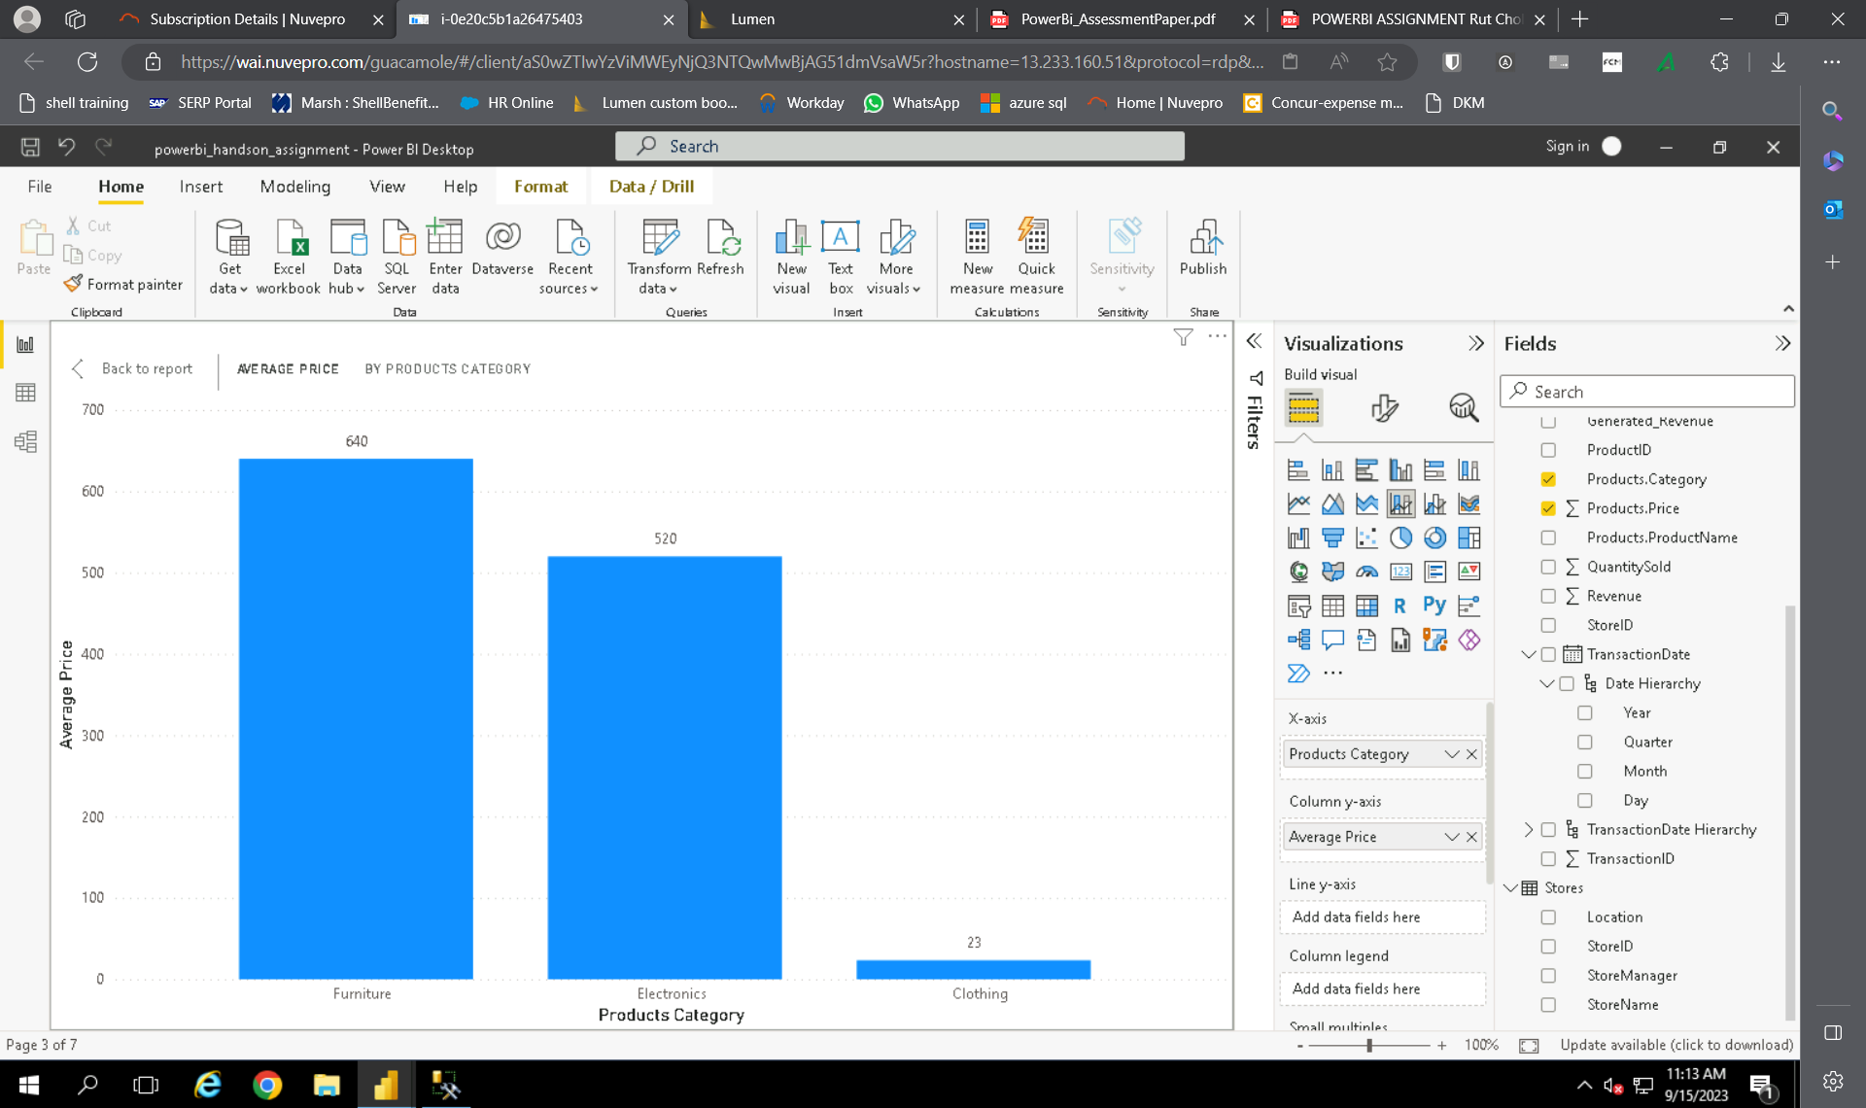

4.

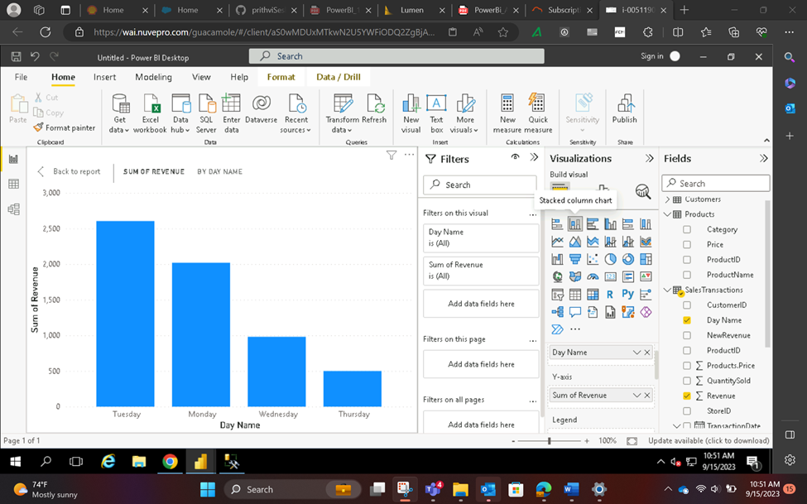

5.

Using slicer we can see trend of product category

For each product the graph shows total quantity sold in all months

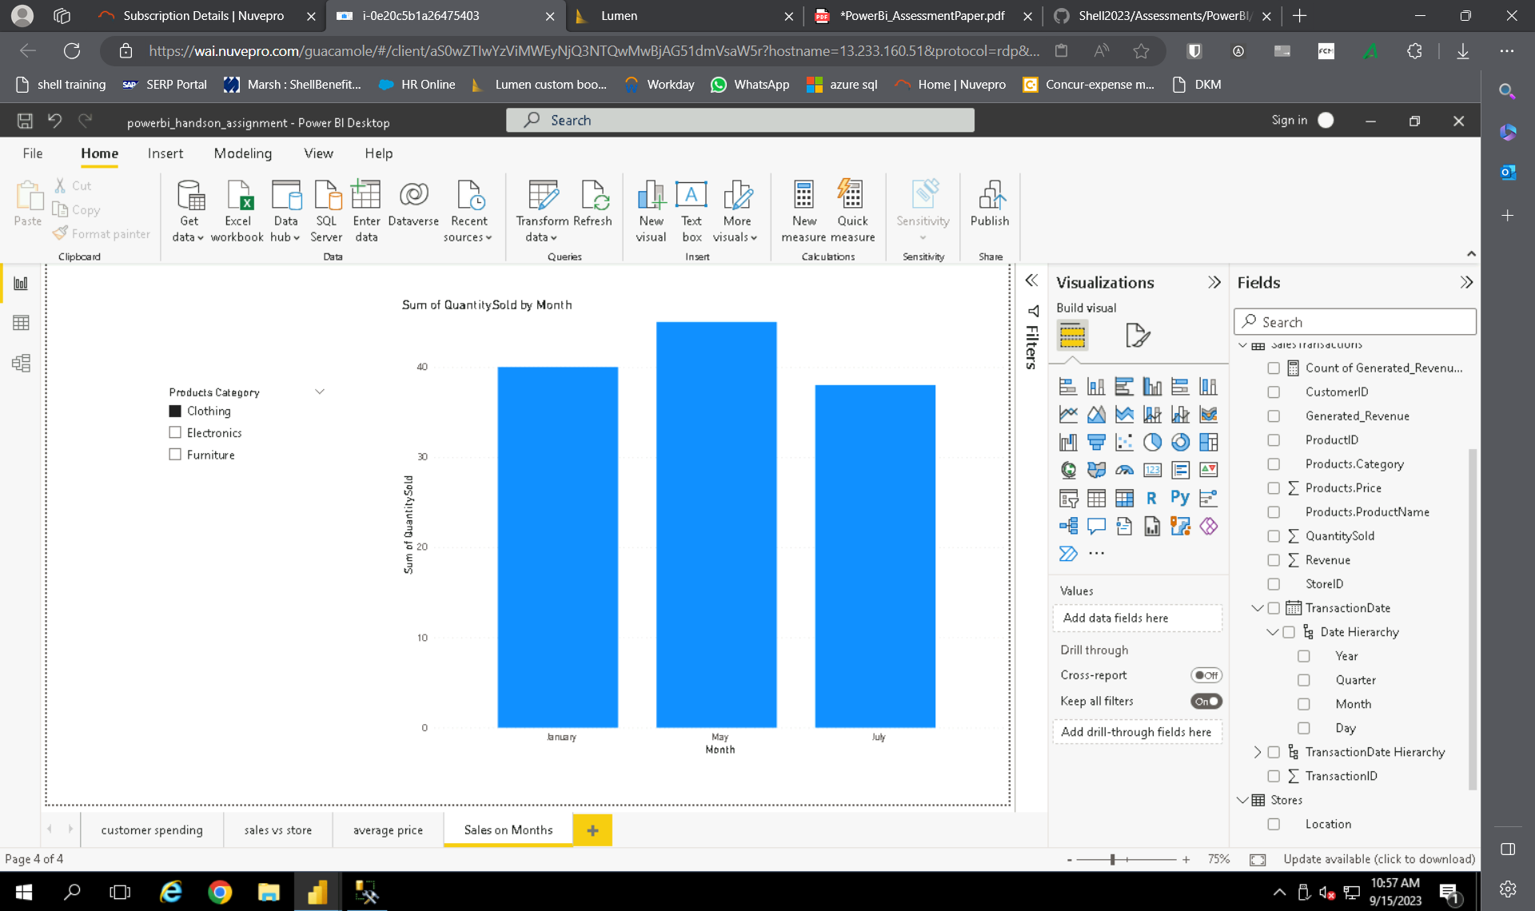

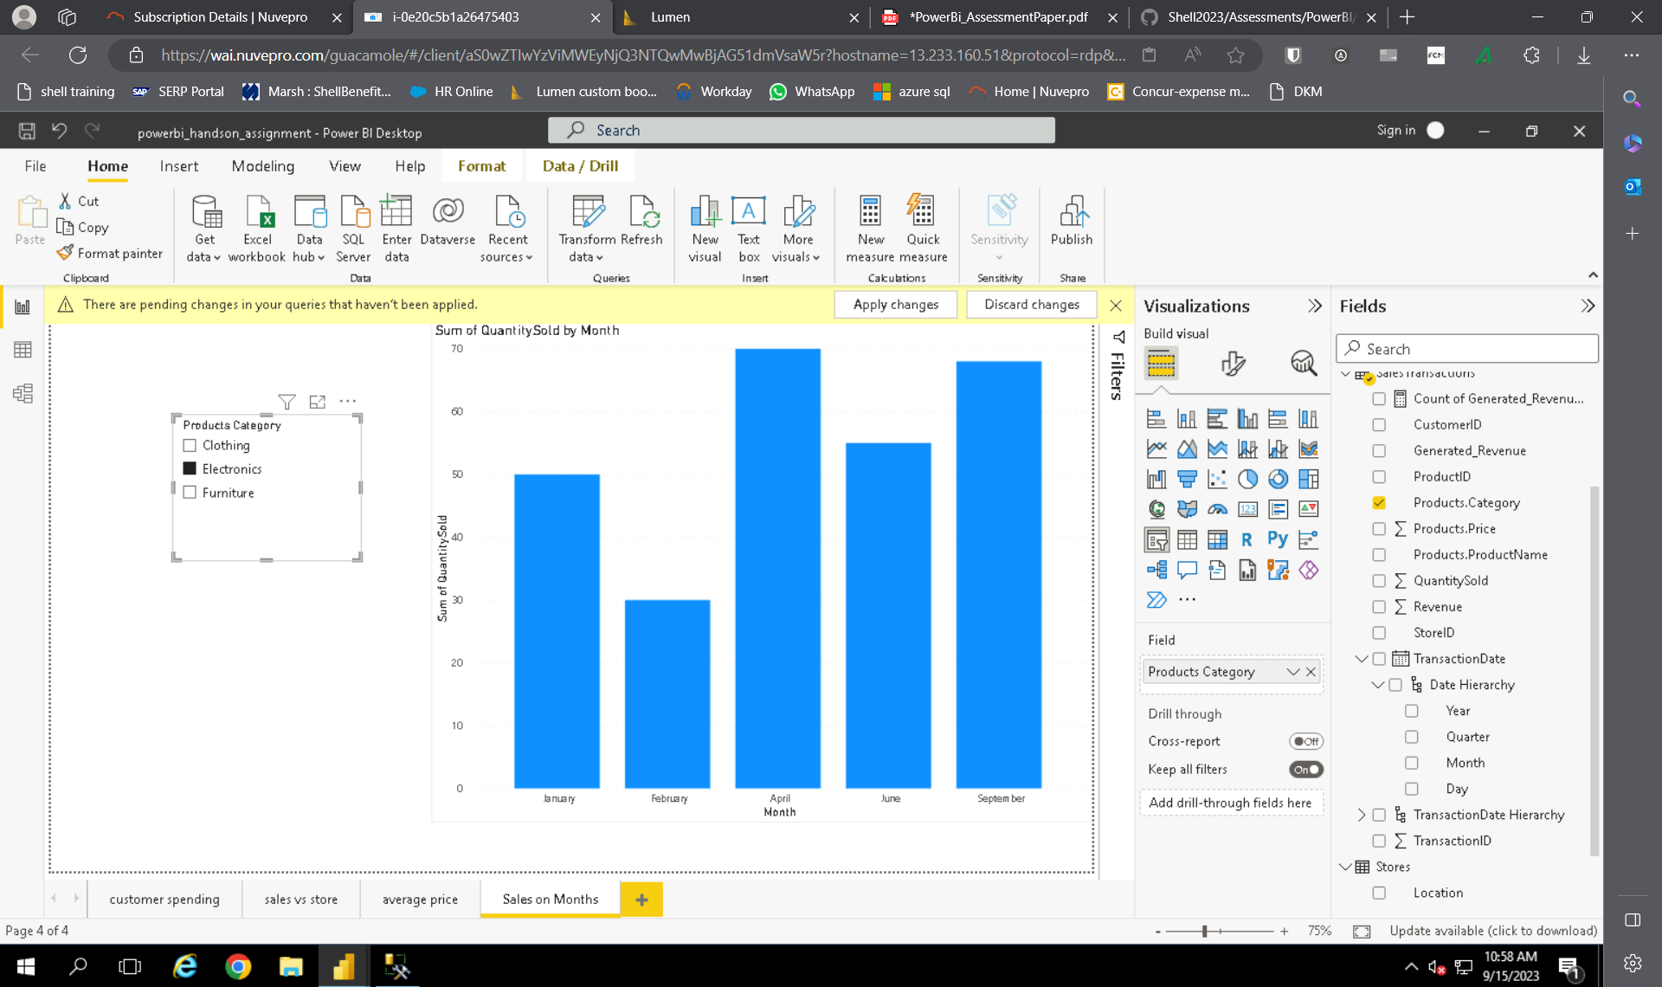

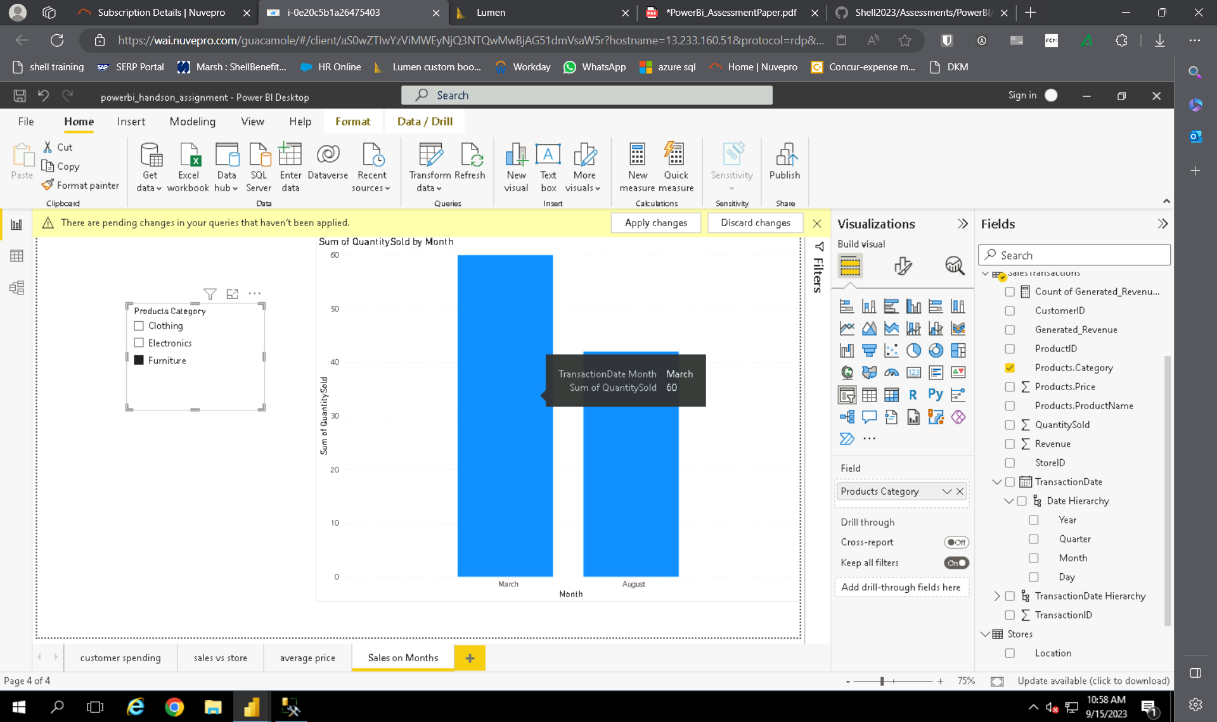

7.

8.

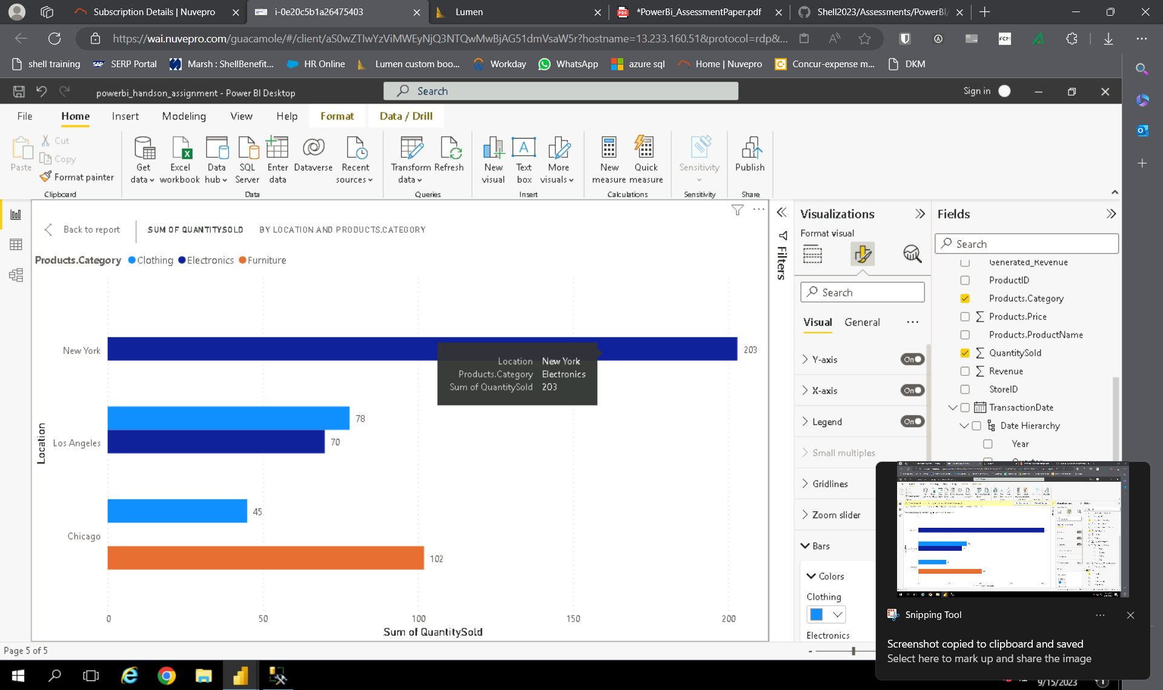

9

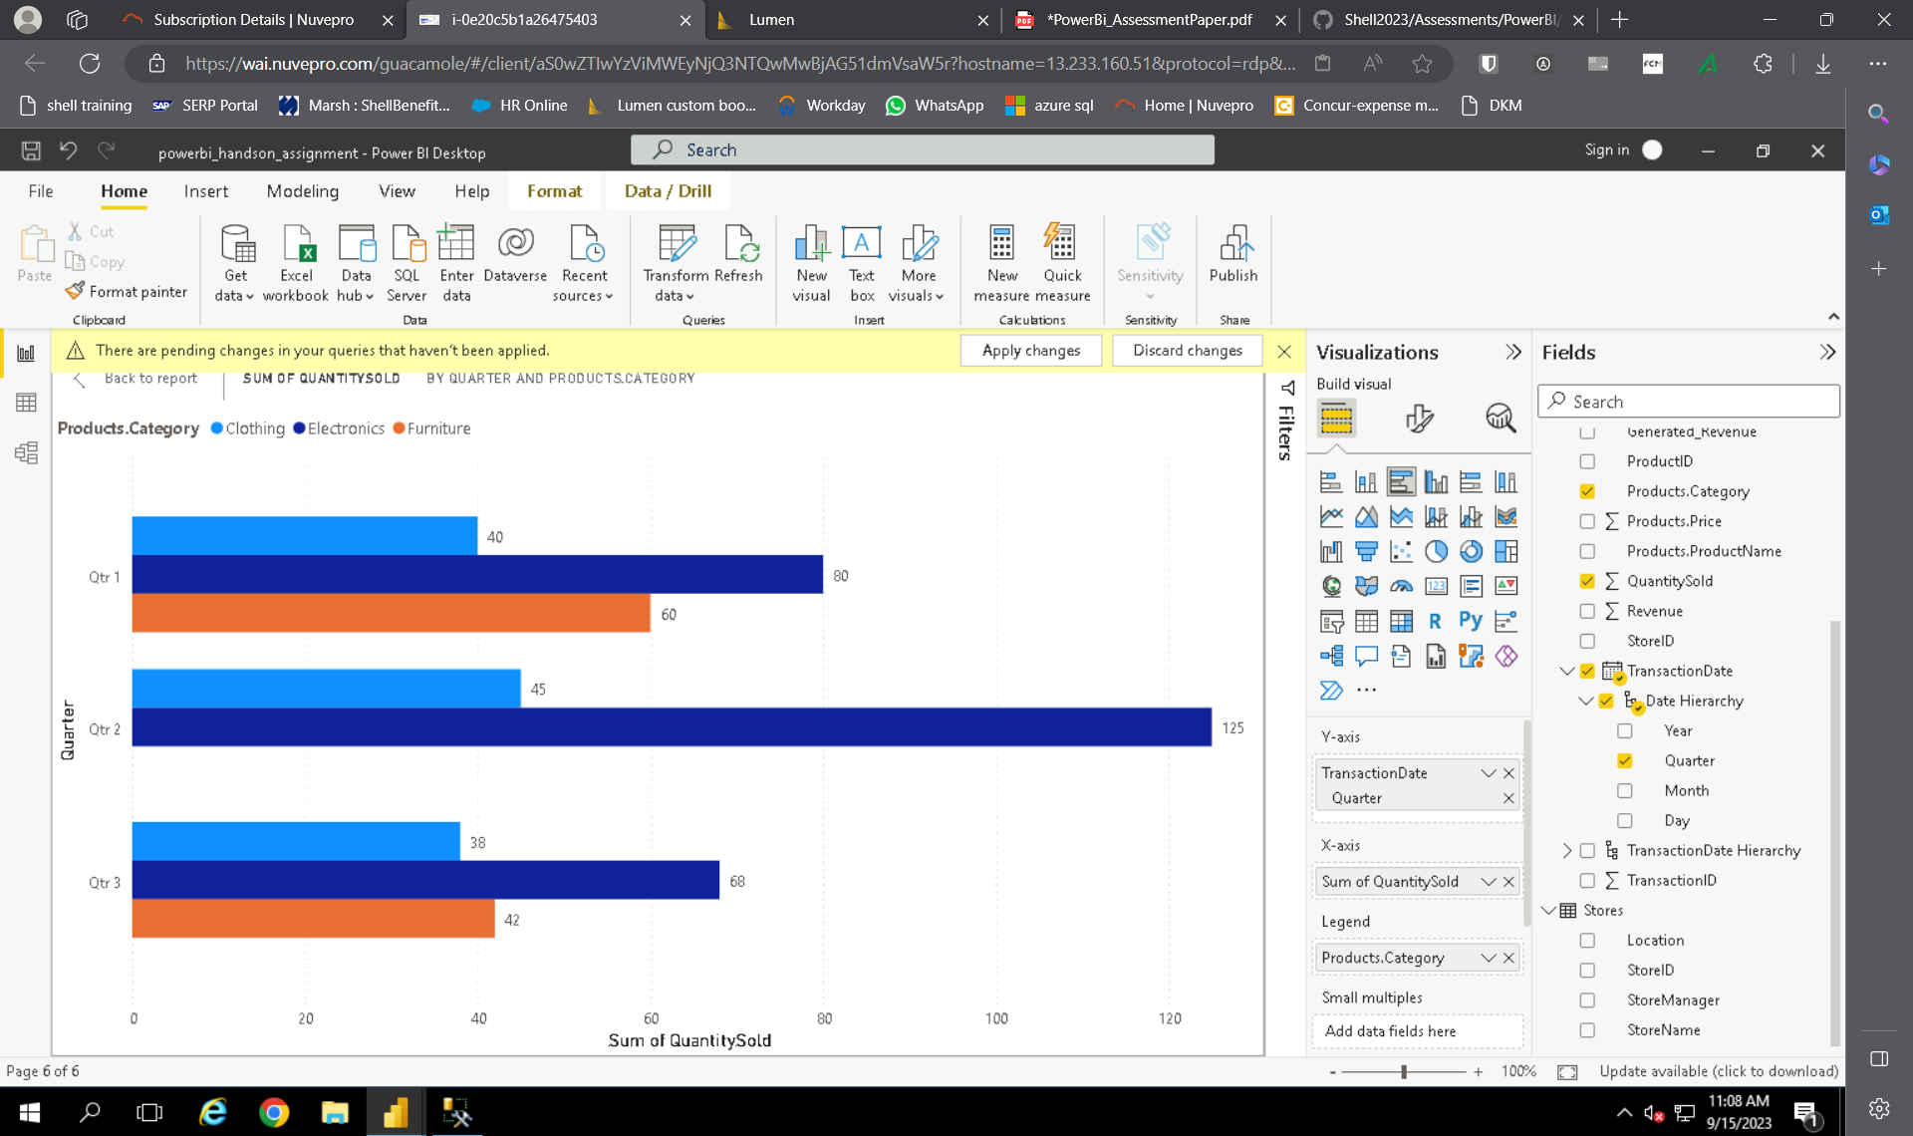

10.